Below are two illustrations relating to the impact of digital technology on supply chain:
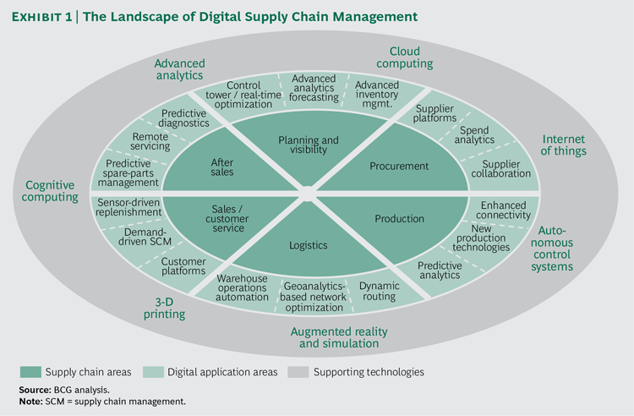
Figure 1: https://www.bcgperspectives.com/content/articles/supply-chain-management-technology-digital-three-paths-advantage-digital-supply-chains/

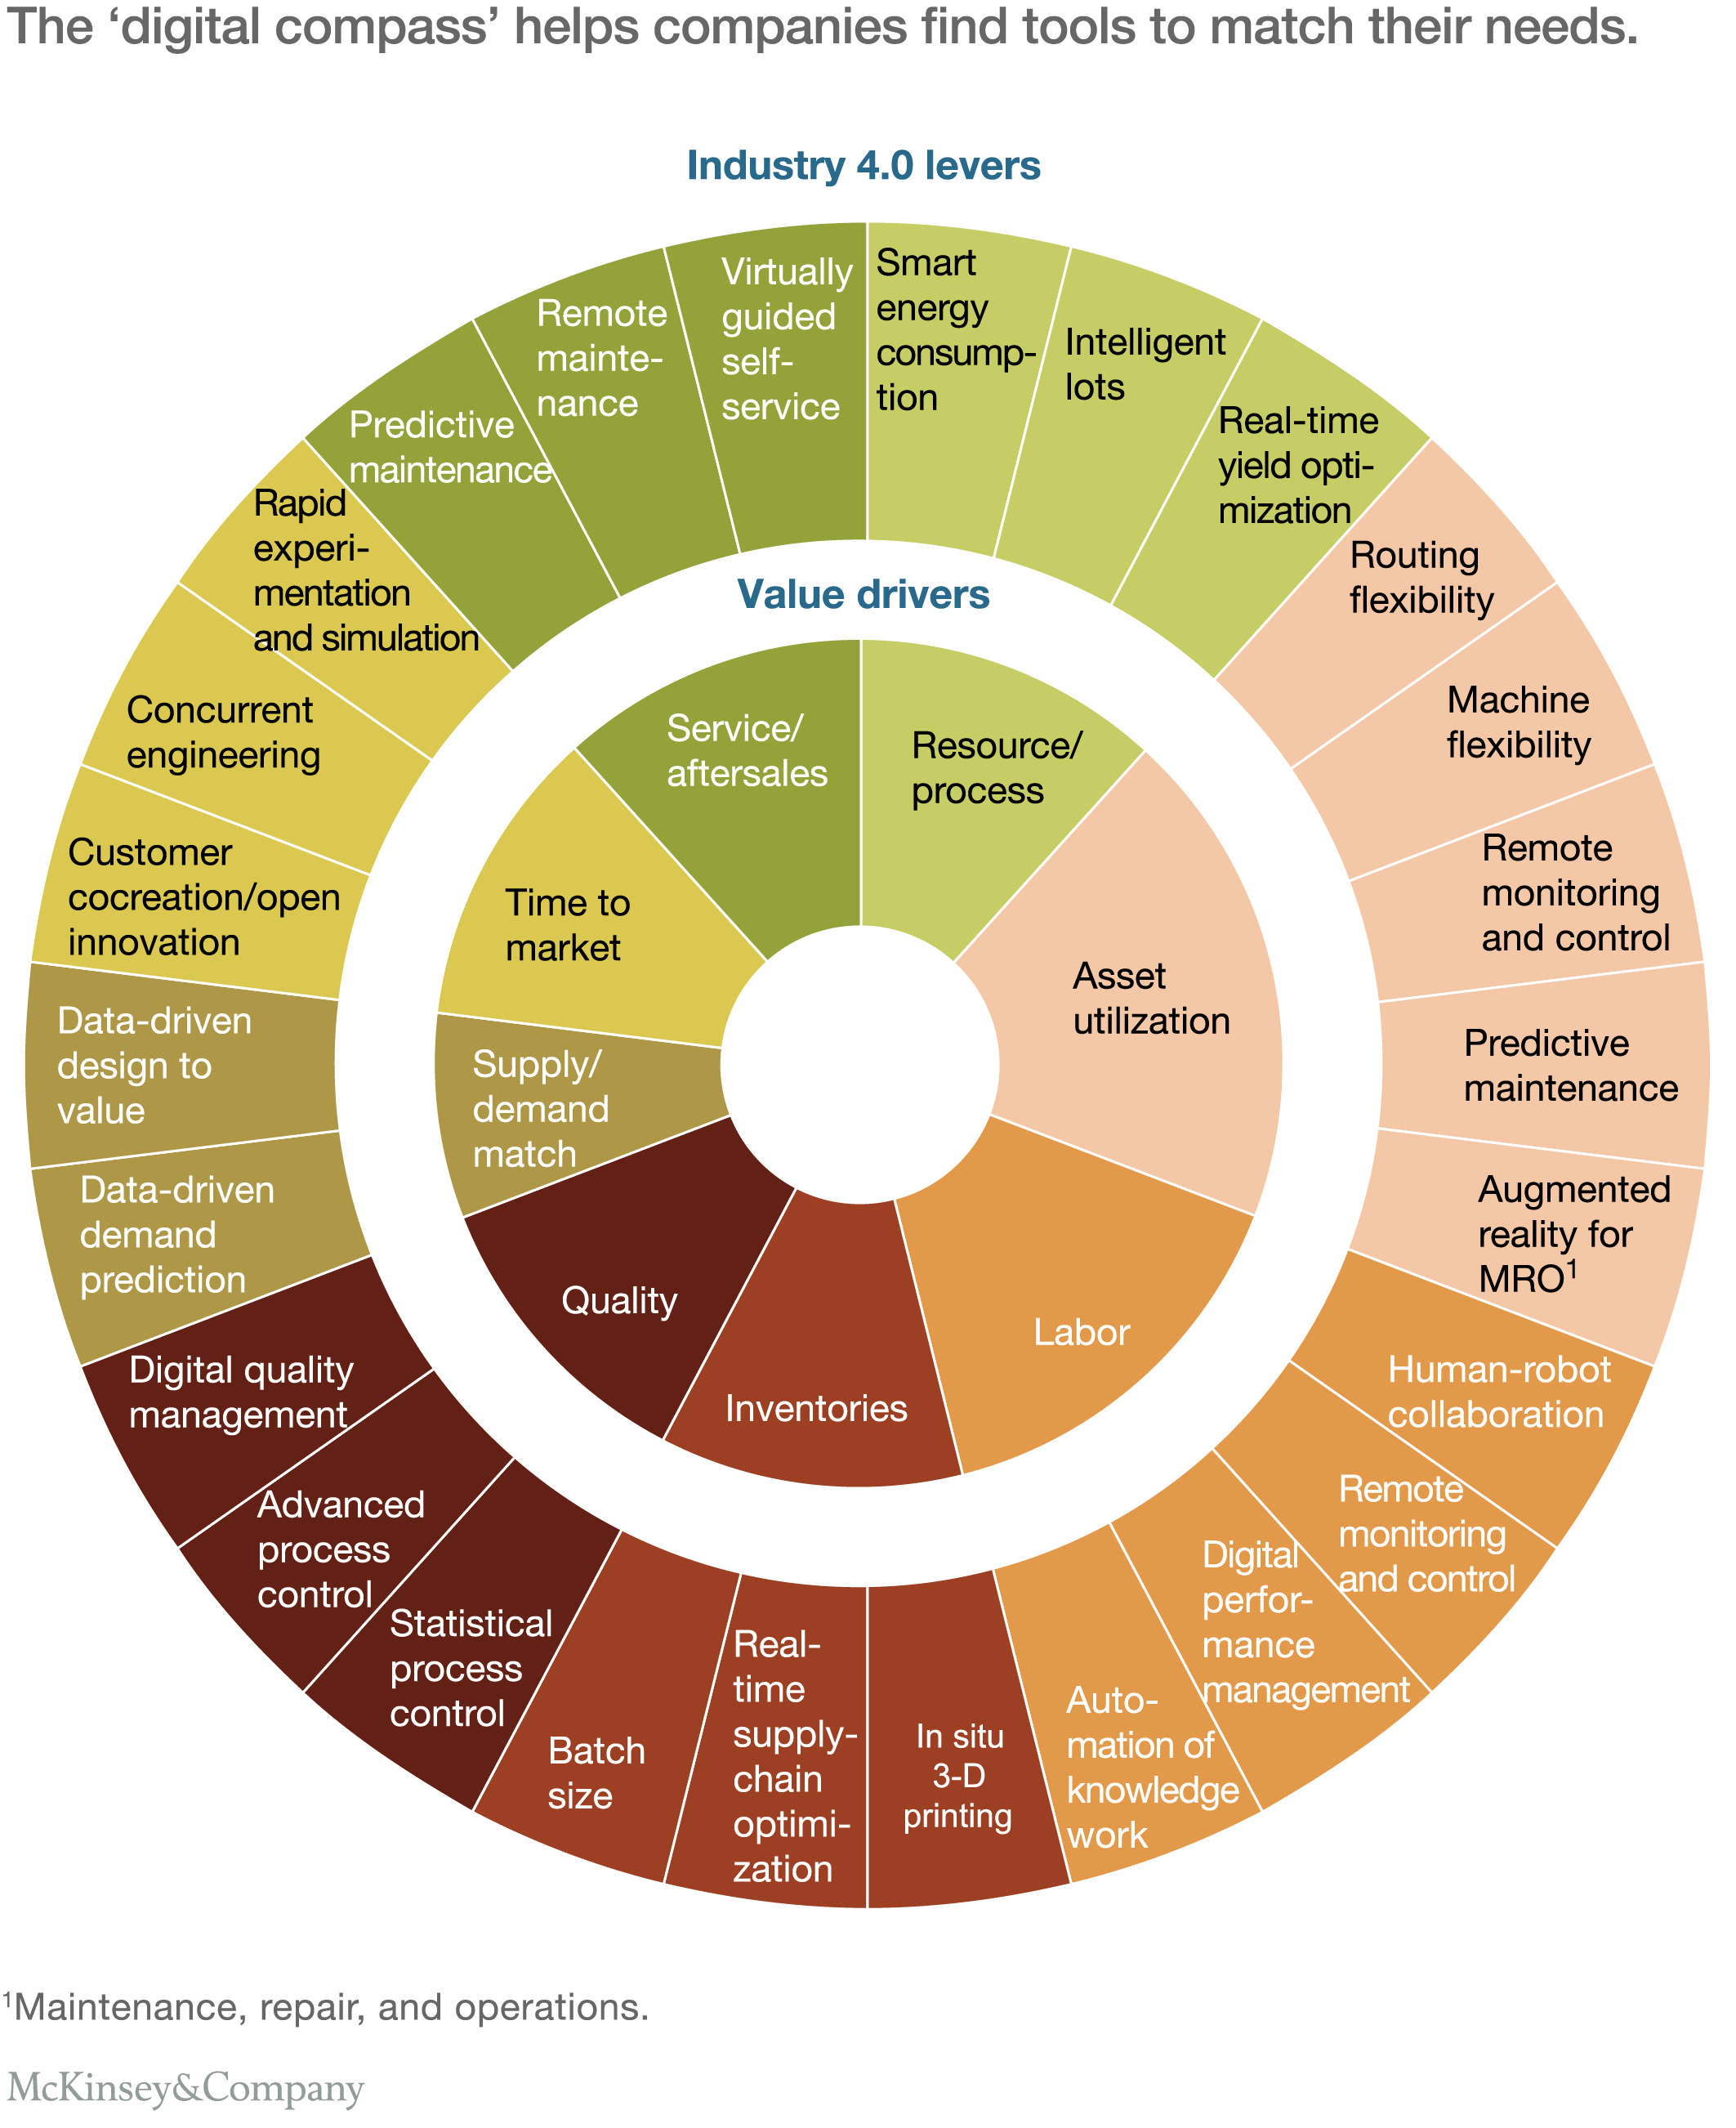
Figure 2: http://www.mckinsey.com/business-functions/operations/our-insights/manufacturings-next-act
Against the backdrop of these two illustrations answer the following two questions:
- Discuss the potential implications from digital technology on the supply chain from agricultural production of grain to the sales of gluten free bread on the shelf in a supermarket
- Outline an innovation strategy for a small/medium sized company that is today producing gluten free bread in a traditional supply chain, enabling this company to benefit from the emerging digital technology.
Tips: explore the impact on digital technology from each phase on supply chain (today vs tomorrow)

